Peninsula College and Fort Worden
Present
The Germans: Schopenhauer
Wesley Cecil PhD.

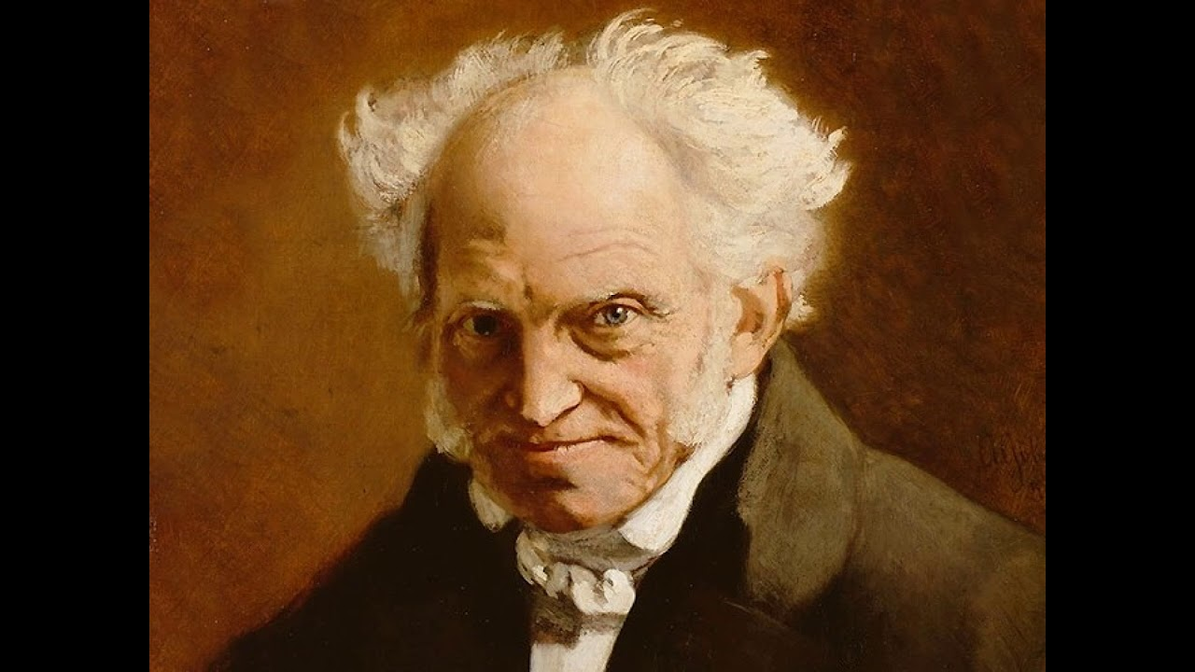

Born 1788 Died 1860
Born to a merchant family in Danzig, Schopenhauer left the family trade after his father’s death freed him from financial constraints. His mother moved to Weimar and became friends with Goethe and had a eminent literary career in her own right. Schopenhauer briefly lived with his mother but they did not get along well. He moved to the University of Gottingen in 1809 then the University of Berlin where he studied medicine, science and philosophy. 1813-1818 were his seminal years in which he wrote his dissertation and his major work – The World as Will and Idea. In 1820 he moved to Berlin where he launched a brief and unsuccessful academic career. He travelled extensively, continued to study and write and after another stay in Berlin settled in 1832 in Frankfurt for the rest of his life. He continued to write, publish and slowly attract the notice of a broader philosophical world. In the 1840s his influence and renown began to grow until he was quite well known at the time of his death.
"THE world is my idea":— this is a truth which holds good for everything that lives and knows, though man alone can bring it into reflective and abstract consciousness. If he really does this, he has attained to philosophical wisdom. It then becomes clear and certain to him that what he knows is not a sun and an earth, but only an eye that sees a sun, a hand that feels an earth; that the world which surrounds him is there only as idea, i.e., only in relation to something else, the consciousness, which is himself. If any truth can be asserted a priori, it is this: for it is the expression of the most general form of all possible and thinkable experience: a form which is more general than time, or space, or causality, for they all presuppose it; and each of these, which we have seen to be just so many modes of the principle of sufficient reason, is valid only for a particular class of ideas; whereas the antithesis of object and subject is the common form of all these classes, is that form under which alone any idea of whatever kind it may be, abstract or intuitive, pure or empirical, is possible and thinkable. No truth therefore is more certain, more independent of all others, and less in need of proof than this, that all that exists for knowledge, and therefore this whole world, is only object in relation to subject/perception of a perceiver, in a word, idea. This is obviously true of the past and the future, as well as of the present, of what is farthest off, as of what is near; for it is true of time and space themselves, in which alone these distinctions arise. All that in any way belongs or can belong to the world is inevitably thus conditioned through the subject, and exists only for the subject. The world is idea. World as Will and Representation
In fact, the meaning for which we seek of that world which is present to us only as our idea, or the transition from the world as mere idea of the knowing subject to whatever it may be besides this, would never be found if the investigator himself were nothing more than the pure knowing subject (a winged cherub without a body). But he is himself rooted in that world; he finds himself in it as an individual, that is to say, his knowledge, which is the necessary supporter of the whole world as idea, is yet always given through the medium of a body, whose affections are, as we have shown, the starting-point for the understanding in the perception of that world. His body is, for the pure knowing subject, an idea like every other idea, an object among objects. Its movements and actions are so far known to him in precisely the same way as the changes of all other perceived objects, and would be just as strange and incomprehensible to him if their meaning were not explained for him in an entirely different way. Otherwise he would see his actions follow upon given motives with the constancy of a law of nature, just as the changes of other objects follow upon causes, stimuli, or motives. But he would not understand the influence of the motives any more than the connection between every other effect which he sees and its cause. He would then call the inner nature of these manifestations and actions of his body which he did not understand a force, a quality, or a character, as he pleased, but he would have no further insight into it. But all this is not the case; indeed, the answer to the riddle is given to the subject of knowledge who appears as an individual, and the answer is will. World as Will and Representation
When we read, another person thinks for us: we merely repeat his mental process. It is the same as the pupil, in learning to write, following with his pen the lines that have been pencilled by the teacher. Accordingly, in reading, the work of thinking is, for the greater part, done for us. This is why we are consciously relieved when we turn to reading after being occupied with our own thoughts. But, in reading, our head is, however, really only the arena of some one else's thoughts. And so it happens that the person who reads a great deal—that is to say, almost the whole day, and recreates himself by spending the intervals in thoughtless diversion, gradually loses the ability to think for himself; just as a man who is always riding at last forgets how to walk. Such, however, is the case with many men of learning: they have read themselves stupid. For to read in every spare moment, and to read constantly, is more paralysing to the mind than constant manual work, which, at any rate, allows one to follow one's own thoughts. Parerga and Paralipomena
Next Lecture December 19th Nietzsche
Lectures Available on Youtube or at www.Wescecil.com

