Peninsula College and Fort Worden
Present
The Germans: Kierkegaard
Wesley Cecil PhD.

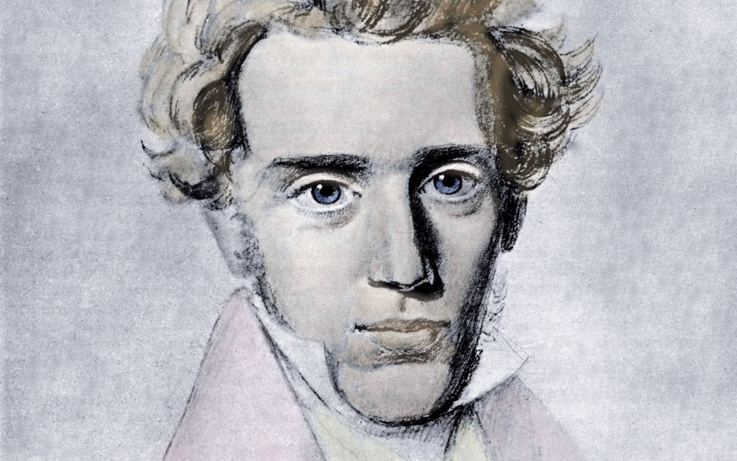

1813-1855

What I really need is to get clear about what I must do, not what I must know, except insofar as knowledge must precede every act. What matters is to find a purpose, to see what it really is that God wills that I shall do; the crucial thing is to find a truth which is truth for me, to find the idea for which I am willing to live and die. Journal 1835
Let others complain that the age is wicked; my complaint is that it is paltry; for it lacks passion. Men’s thoughts are thin and flimsy like lace, they are themselves pitiable like the lacemakers. The thoughts of their hearts are too paltry to be sinful. For a worm it might be regarded as a sin to harbor such thoughts, but not for a being made in the image of God. Their lusts are dull and sluggish, their passions sleepy. Either/Or

One sticks one’s finger into the soil to tell by the smell in what land one is: I stick my finger in existence — it smells of nothing. Where am I? Who am I? How came I here? What is this thing called the world? What does this world mean? Who is it that has lured me into the world? Why was I not consulted, why not made acquainted with its manners and customs instead of throwing me into the ranks, as if I had been bought by a kidnapper, a dealer in souls? How did I obtain an interest in this big enterprise they call reality? Why should I have an interest in it? Is it not a voluntary concern? And if I am to be compelled to take part in it, where is the director? I should like to make a remark to him. Is there no director? Whither shall I turn with my complaint? Repetition
When it is stated in Genesis that God said to Adam, “Only from the tree of the knowledge of good and evil you must not eat,” it follows as a matter of course that Adam really has not understood this word, for how could he understand the difference between good and evil when this distinction would follow as a consequence of the enjoyment of the fruit. When it is assumed that the prohibition awakens the desire one acquires knowledge instead of ignorance, and in that case Adam must have had knowledge of freedom, because the desire was to use it. The explanation is therefore subsequent. The prohibition induces in him anxiety, for the prohibition awakens in him freedom’s possibility. What passed by innocence as the nothing of anxiety has now entered into Adam, and here again it is a nothing-the anxious possibility of being able. He has no conception of what he is able to do; otherwise-and this it what usually happens-that which comes later, the difference between good and evil, would have to be presupposed. Only the possibility of being able is present as a higher form of ignorance, as a higher expression of anxiety, because in a higher sense it both is and is not, because in a higher sense he both loves it and flees from it. Concept of Anxiety
Some of the writers and thinkers influenced by Kierkegaard: Franz Kafka, Emmanuel Levinas and Jacques Derrida, Gabriel Marcel, Lev Shestov, Paul Tillich, Martin Buber, Gyorgy Lukacs, Karl Barth, Georges Battaille, Rudolf Bultmann, Karl Jaspers, Michel Henry and Wittgenstein.

Next Lecture February 20th Karl Jaspers
Lectures Available on Youtube or at www.Wescecil.com

