Peninsula College and Fort Worden
Present
The Germans: Hegel
Wesley Cecil PhD.
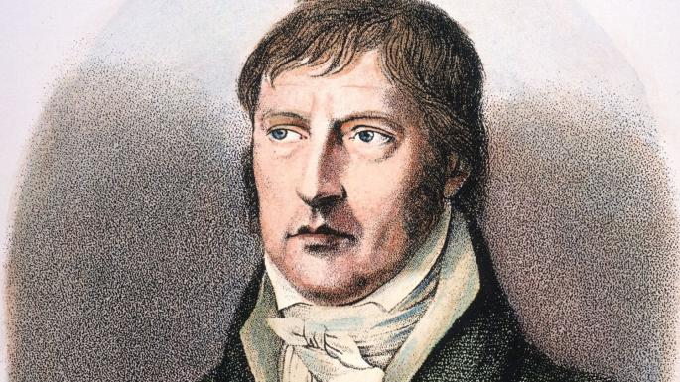

Born 1770 Stuttgart
1788 – Tubingen Seminary
1789 French Revolution
1793 Bern Tutor for an Aristocratic family.
1801-1816 Jena, Bamberg, Nuremberg
1804 Napoleon declares himself Emperor
1814 Congress of Vienna
1818 University of Berlin (Prussian Power Center)

With self-consciousness, then, we have now passed into the native land of truth, into that kingdom where it is at home. We have to see how the form or attitude of self-consciousness in the first instance appears. When we consider this new form and type of knowledge, the knowledge of self, in its relation to that which preceded, namely, the knowledge of an other, we find, indeed, that this latter has vanished, but that its moments have, at the same time, been preserved; and the loss consists in this, that those moments are here present as they are implicitly, as they are in themselves. The being which “meaning” dealt with, particularity and the universality of perception opposed to it, as also the empty, inner region of understanding – these are no longer present as substantial elements (Wesen), but as moments of self-consciousness, i.e. as abstractions or differences, which are, at the same time, of no account for consciousness itself, or are not differences at all, and are purely vanishing entities (Wesen). Phenomenology of Mind
History, is a conscious, self-meditating process — Spirit emptied out into Time; but this externalization, this kenosis, is equally an externalization of itself; the negative is the negative of itself. ... Thus absorbed in itself, it is sunk in the night of its self-consciousness; but in that night its vanished outer existence is perserved, and this transformed existence — the former one, but now reborn of the Spirit's knowledge — is the new existence, a new world and a new shape of Spirit. Phenomenology of Spirit
The history of philosophy begins where thought in its freedom come into existence, where it cuts itself loose from its immersion in and unity with nature, constitutes itself for itself, wehre thinking goes into itself and remains itself. From the historical point of view this emergence of spirit is intimately connected with the flowering of political liberty; and political liberty, liberty within the state, begins where the individual fells himself to be an individual (Introduction to the History of Philosophy).
In this way the Idea is elevated to Spirit. . . . The principle of absolute being-for-itself or of freedom . . . wherein the determination is precisely this, that as such man has an infinite worth. (Introduction to the History of Philosophy).

Next Lecture November 21st Schopenhauer

Lectures Available on Youtube or at www.Wescecil.com

