Peninsula College and Fort Worden
Present
The Germans: Karl Jaspers
Wesley Cecil PhD.

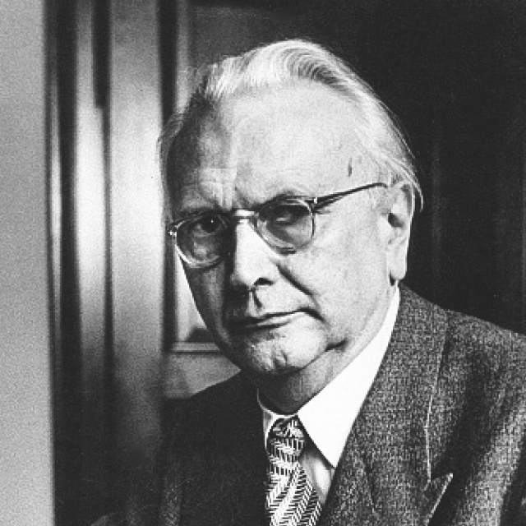

Born 1883 Died 1969
My path was not the normal one of professors of philosophy. I did not intend to become a doctor of philosophy by studying philosophy (I am in fact a doctor of medicine) nor did I by any means, intend originally to qualify for a professorship by a dissertation on philosophy. To decide to become a philosopher seemed as foolish to me as to decide to become a poet. Since my schooldays, however, I was guided by philosophical questions. Philosophy seemed to me the supreme, even the sole, concern of man. Yet a certain awe kept me from making it my profession. On My Philosophy
Philosophical thought must always spring from free creation. Every man must accomplish it for himself. A marvelous indication of Man’s innate disposition to philosophy is to be found in the questions asked by children . . . A child cries out in wonderment, “I keep trying to think that I am somebody else, but I’m always myself.” Way to Wisdom
Thus Every object, every thought content stands in two-fold dichotomy, first in reference to me, the thinking subject, and secondly in reference to other objects. As thought content it can never be everything, never the whole being, never being itself. Whatever is thought must break out of the comprehensive. Way to Wisdom

The independence of man is rejected by all totalitarianism, by the totalitarian religion which claims exclusive truth as well as by the totalitarian state which, melting down all humanity into material for its edifice of power, leaves no room for individuality and even controls leisure activities in accordance with an ideological line. Today independence seems to be silently disappearing beneath the inundation of life by the typical, the habitual, the unquestioned commonplace. But to philosophize is to fight for our inner independence, under all conditions. Way to Wisdom

Philosophy after Kierkegaard and Nietzsche can no longer bring its thought into a single, complete system to be brought out as a presentation derived from its principles. It is a questions of letting those principles themselves become effective. The problem for us is to philosophize without being exceptions, but with our eyes on the exception. Reason and Existenz

We cannot avoid conflict, conflict with society, other individuals and with oneself. Conflicts may be the sources of defeat, lost life and a limitation of our potentiality but they may also lead to greater depth of living and the birth of more far-reaching unities, which flourish in the tensions that engender them. General Psychopathology

Next Lecture March 19th Hannah Arendt
Lectures Available on Youtube or at www.Wescecil.com

